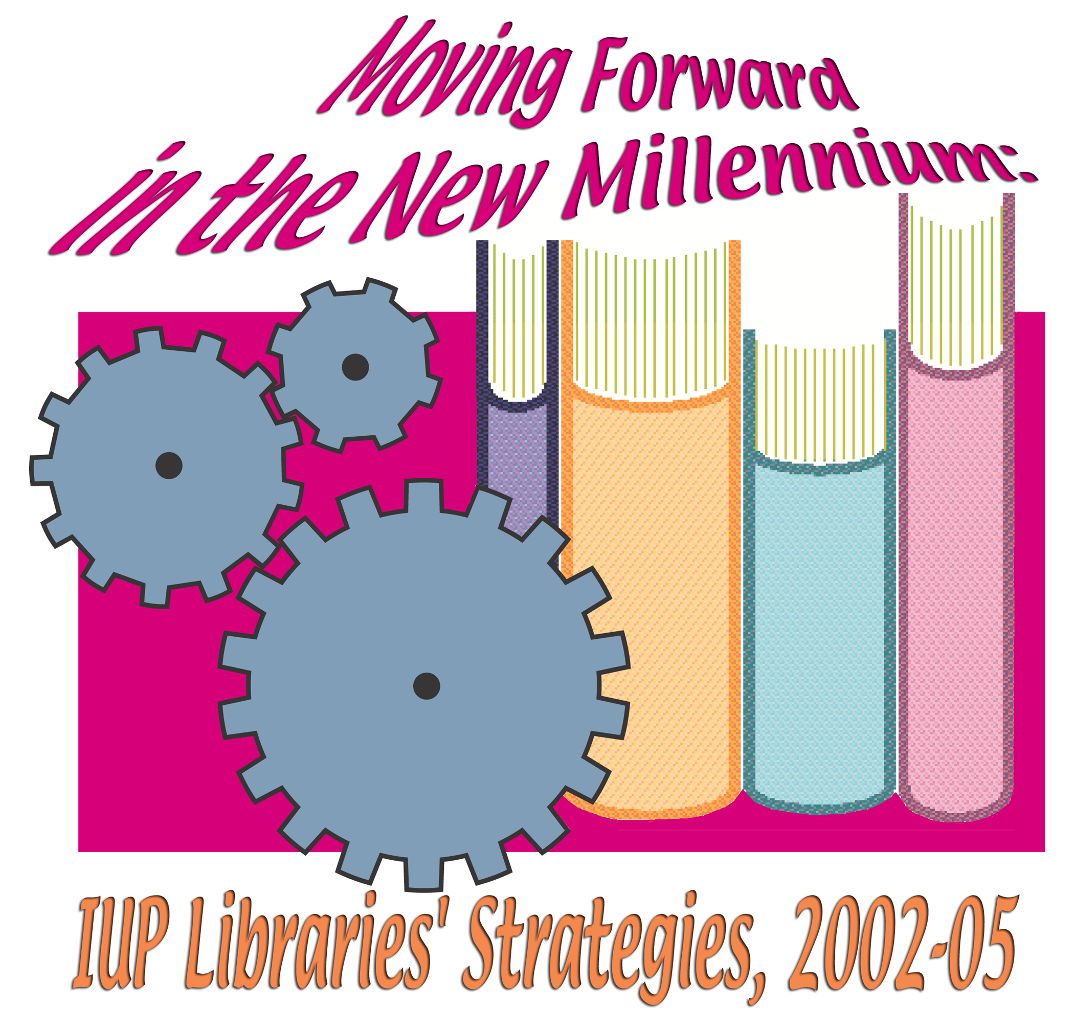

Introduction

The IUP Libraries implemented its Strategies for a New Millennium: A Plan for IUP Libraries in 1999. This plan outlined goals and strategies for a three-year period and has been completed successfully. There were many goals and strategies and a commendable percentage was completed or evaluated as in progress. It is now time to move forward with a new strategies plan. Again this document, a product of the teamwork of library staff, managers and faculty, provides us with goals and strategies for the next three years.

The Libraries’ Mission Statement has not changed over the last three years. Demands on our resources and changing trends continue to impact our services in different ways from three years ago but we remain committed to

…provide support for teaching, research and the personal enrichment of members
of the IUP community. This role is fulfilled through a combination of growing
collections in print and non-print formats, which are supplemented by the
informational, instructional and media services administered by a professionally
trained staff.

Higher education is changing rapidly with the students expecting and being offered a wider variety of ways of acquiring knowledge. The Libraries’ dedication to participating in this educational and learning revolution is part of the driving force behind the planning process. We recognize that we are not a passive player in the academic community, that we play an active and central role in our learning and cultural community. Having implemented and completed a successful strategies plan, the Libraries have recognized the importance and value of working in this milieu. The new plan acknowledges our past successes and provides us with the guidelines for moving forward and fulfilling our mission:

The University Libraries will continue to be innovative and experimental as they
strive to meet changing needs with a blend of traditional and non-traditional
methodology.

The Libraries will continue to develop partnerships and be a leader in the Information Literacy initiatives on campus. The planned life cycle renovation of Stabley in 2003 and the implementation of an Information Commons will enhance the Libraries as a focal point for the academic and campus communities.

Planning Process for 2001-2002

September-November
In September and October, the staff, managers and faculty analyzed the list of goals and strategies which was the focus of the Strategies for a New Millennium. Of these 15 goals with 48 strategies, 67% of the strategies were accomplished, 23% were in progress and 10% were not satisfactorily approached. It was agreed that Lou Wetherby, the consultant, return to offer a workshop to address the issue of successful meetings and trends in library technology. Successful meetings was agreed as one of the important, unmet goals, which needed to be addressed. Trends in library technology would prepare staff for thinking about the new plan. The Planning Committee would be convened at the beginning of the Spring Term.

December

Lou Wetherby conducted a one-day workshop. The first part was devoted to issues relating to conducting successful meetings. This was considered a priority for staff morale and to facilitate an efficient planning process. The second part addressed trends in library technology.

February-March

The Planning Committee was reconvened with the following members: Judy Bouton [Circulation], Barb Barber [Media Resources], Liz Evans [Administration], Rena Fowler [Administration], Glenn Himes [Media Services], Joann Janosko [Acquisitions/Serials], Bob Kirby [Punxsutawney Campus], Dan Shively [Cataloging], Ed Zimmerman [Library Technology Services], Phil Zorich [Special Collections]. The following themes were identified for the basis of the new planning document: Instructional Services, Staff Development, Facilities [Real & Virtual] Planning & Development, Community Outreach, Resources & Technology and Technology Integration. Subcommittees, led by committee members, met to discuss these themes to construct goals and strategies. Members of the subcommittees included Sue Drummond, Portia Diaz-Martin, Sandy Janicki, Carol Connell, Theresa McDevitt, Blaine Knupp, Walt Laude, Barb Barber, Melonie Payne, Karen Brown, Lester Bowser. The committee discussed the findings of the subcommittees.

April-June
The draft plan was produced and revised by the committee. It was submitted to the entire staff of the Libraries for comments and suggestions. The committee revised the final draft and produced the final document to forward to the Provost.

Summer-Fall

The plan is to be presented to and discussed with the Provost. The new plan will be linked from the Libraries’ home page.

Vision and Values

The library faculty, managers and staff members of the IUP Libraries affirm the following statement:

Vision

We envision a future for IUP Libraries

- Where the services are prompt, satisfying and effective, drawing together the expectations of users with the discipline of librarianship;
- Where students and other university community members may learn how to locate, access and use resources as part of becoming information literate, life-long learners;
- Where university community members engage in active learning, independently or collaboratively, in one of the IUP Libraries, or through our gateway website;
- Where librarians and staff deliver services in a friendly and professional manner, partnering with teaching faculty and other university staff in the development of services;
- Where the information resources are rich, well-matched to the curriculum, up-to-date, well-maintained and easily accessible to local and remote users.

We also envision a future for IUP Libraries where all staff enjoy their work and are fulfilled by it.

Values

As employees of the IUP Libraries, we are committed to work with each other in a friendly, honest and open environment that demonstrates mutual respect for our strengths and differences. In serving our users, we place high value on quality and timeliness of service provided in a professional manner.

UP Libraries: Goals and Strategies

Theme 1
Instructional Services

Goal 1: Better integrate information access and literacy into the general curriculum,
thereby contributing to improved retention and diversity.

Strategies
- Pilot targeted LS499 offerings that include an information literacy component
- Work with Dean Carter to explore an experimental collaborative program
with English101 and 202
- Establish a 3-credit information access and evaluation class as an elective for the Liberal Studies Curriculum.
- Continue to offer LIBR151.
- Co-operate with the Learning Center.

Goal 2: Enhance and promote Bibliographic Instruction activities and capabilities of the
Library.

Strategies:
- Rename BI to Information Access and Evaluation (IA&E) and establish a logo that would be promoted on instruction web pages, flyers, certificates, and posters in the Library and across campus.
- Expand the teaching role of librarians as a key component in student retention efforts, by helping students succeed in their course work.
- Develop and publicize on-line tutorials.
- Offer workshops related to information access and evaluation to university undergraduate and graduate students, and faculty independent of credit courses.
- Explore instructional services for the Honors College.

Goal 3: Support library staff in the development and delivery of instructional modes and
methods to promote library services.

Strategies:
- Offer workshops to equip staff with means and methods of providing instruction.
- Offer guides on instructional design and pedagogical approaches.
- Develop and offer templates and tools to facilitate instruction.

Goal 4: Explore the needs of our academic community that might be met by the proposed
Information Commons.

Strategies:
- Strengthen relationships with faculty across the academic community to discover their needs. Work with department chairs to discover future curricular innovations that the library can facilitate through the Information Commons.
- Model the use of new media by students in our own curriculum.

Goal 5: Create and develop a plan to help library staff to use and re-use technology-
based methods to support digital pedagogy.

Strategies:
- Pursue technical literacy in the tools we have available to develop instruction.
- Exploit various means of resource sharing of instructional devices and materials.

Theme 2

Staff Development

Goal 1: Facilitate staff training in the new library technologies.

Strategies:
- Provide incentives, resources, training time and identify trainers for group and individual training.
- Evaluate the type of training needed and by whom.
- Emphasize staff development in use of and support for WebCT.

Goal 2: Organize a group of staff to oversee the training of library student employees in
basic library policies and procedures.

Strategies:
- Evaluate the use and deployment of student workers for maximum effectiveness and encourage cross training and teamwork among student employees.
- Encourage student employees to act responsibly and professionally.

Goal 3: Encourage library staff to evaluate their own job descriptions, rewrite
them as necessary and pursue reclassification if justified.

Strategy:
Provide clear, timely and accurate information via Human Resources.

Goal 4: Organize a group of library faculty and staff to handle social obligations such as

retirement parties, flowers/cards for funerals, accidents/surgeries, morale

boosting activities such as Holiday lunches.

Strategy:
Encourage volunteers to work on this committee for a one-year period. Each subsequent year different people will be asked to join.

Theme 3

Facilities [Real & Virtual] Planning & Development

GOAL 1: Carry out Stabley Renovation.

Strategy:
Pursue process already in progress, providing for interim housing of staff and material.

GOAL 2: Draw up a plan for Phase II, Stapleton.

Strategy:
Create task force to revisit Capital Facilities Plan, revise and expand this document. Work with Director of Facilities Management to develop plan. Within time frame of the new Strategies Plan [3 years], strive for the approval of the plan for Stapleton Phase II by the campus and system.

GOAL 3: Provide for life-cycle maintenance of Stapleton Library.

Strategy :
Reconvene Building & Space Committee. Consult with Director of Facilities Management. Assess renovation needs.

GOAL 4: Examine & provide for the infrastructure of a viable virtual presence.

Strategies:
- Build a user-friendly web site that delivers all library and information
services. Conduct usability studies on a regular basis.
- In conjunction with Technology Integration (p.10), research networks, DSL, etc. to address the needs of our virtual presence.

GOAL 5: Strive for full ADA compliance in both physical and virtual environments.

Strategies:
- Ensure the virtual web site is ADA compliant.
- Promote current services to students.

Theme 4

Community Outreach

Goal 1: Find ways to develop library’s role as a cultural and intellectual center.

Strategies:
- Explore establishing a book series designed for the general public, e.g. a great books discussion group.
- Explore sponsoring speakers for events, e.g., Black History Month, Women’s History Month.
- Encourage exhibits.
- Offer information training sessions for community members.

Goal 2: Find ways to develop library as a social center.

Strategies:
- Provide a coffee bar.
- Provide comfortable seating with a browsing area adjacent to coffee bar.
- Explore providing space for campus clubs to sell coffee, snacks or to make information available.

Goal 3: Find ways to develop library as a community resource, particularly used by a
diverse population and our non-traditional students.

Strategies:
- Conduct classes through Continuing Education, e.g. Internet Evaluation.
- Conduct workshops for area teachers and librarians.
- Establish a community day, inviting public schools to bring their students.

Goal 4: Promote our resources and services to all members of the communities.

Strategies:
- Cultivate partnerships with student organizations and student services.
- Provide an exhibit of faculty publications.
- Place commercials on IUP TV for specific resources and services.
- Strengthen the faculty liaison program in order to develop library services and resources.
- Offer orientation programs and exhibits for international students.
- Work more closely with branches and off-campus centers.
- Produce service booklets for incoming students and new faculty.
- Increase awareness of Interlibrary Loan, PALCI services and e-reserves.
- Publicize the need for money for collections and resources.

Theme 5

Resources

Goal 1: Improve collection development, preservation and access to our collections in
concrete and practical ways.

Strategies:
- Investigate methods of collection analysis.
- Target specific subject areas as pilot programs to be evaluated so as to identify strengths, weaknesses and gaps.
- Suggest a plan of action for pilot disciplines.
- Expand the pilot project to include all disciplines.

Goal 2: Start a weeding project in the Dewey collection. Continue a weeding project of
LC collections based on the information gathered from the collection analysis process.

Strategies:
- Identify low use items and damaged items for replacement or discard based on collection analysis process.
- Based on Collection Development Policy, make decisions to update, replace, or discard low use and damaged items.

Goal 3: Develop a digital library.

Strategies:
- Incorporate evaluated collections into a useable web page for departments.
- Identify and acquire digital resources to support the disciplines.

Goal 4: Explore improving access to both physical and virtual collections through a
portal or portal-like entity.

Strategy:
Investigate Encompass and other commercial portal products.

Goal 5: Seek to secure funding for the IUP Libraries.

Strategies:
- Raise funds from private sources.
- Learn more about grant writing and seek grants as a vehicle to foster innovation, bringing new expertise.
- Seek a university plan to adequately fund the IUP Libraries.
- Seek funding for areas under accreditation or program review.
- Advocate inclusion of libraries as a line item in grant proposals.

Goal 6: Participate in the program review process as a unit.

Strategy:
Assess IUP Libraries’ resources and services according to national standards and
those offered by peer institutions.

Theme 6

Technology Integration

Goal 1: Enhance information sharing and access to both internal and external resources.

Strategies:
- Develop a working library Intranet.
- Expand or improve access to electronic resources
    - Docutek
    - CDROM Server
    - Wireless
    - Digital Library
    - WebCT
- Ensure backup and fault tolerance solutions are in place for mission critical services.

Goal 2: Focus efforts toward exploiting current technology to the fullest possible extent.

Strategy:
Arrange training sessions for library personnel on the major software packages such as the Microsoft Office Package, WebCal, WebCT, and Voyager.

Goal 3: Ensure that all services in the physical library are also available in the virtual
Library, taking into account the needs of our diverse population.

Strategy:
Provide a virtual reference service utilizing existing technologies that will be effective and efficient, and support online and distance education courses (i.e. creation of a digital ready reference collection).

IUP and Its Context

Strategies for a New Millennium, the IUP Libraries’ first three-year plan was written in the context of both IUP and SSHE plans and goals. This second plan, Moving Forward in the New Millennium: IUP Libraries’ Strategies, 2002-05, builds upon that initial effort, taking into account new directions set forth by the State System for Higher Education, the SSHE library directors, and IUP. The SSHE issued a new set of initiatives for system universities in Imperatives Affirmed in 2001. Last summer, IUP presented to the system its first Performance and Outcomes Plan, 2001-2004, and the university has been attentive to performance measures now set by the system. This spring IUP has adopted two additional performance measures: accreditation as a mission-specific indicator and enrollment in honors programs and courses as an academic quality indicator. These documents and criteria do not explicitly cite libraries. However, library faculty, managers, and staff have examined this information to see how the IUP Libraries might devise its own goals and strategies in order to contribute to larger system and university aims. This effort is reflected in our new document. In addition, the library directors of the SSHE system prepared a plan in 2001, entitled Change, Innovation, and Leadership. The goals described in this report were considered in the development of the new IUP Libraries’ plan.

Trends in Libraries

We need to ask certain questions of the IUP Libraries in order to ascertain whether the Libraries are functioning according to the national and international trends.

Can the Libraries compete successfully in the electronic information world? Can the Libraries provide what the users want, in the format they desire and when they need the resources? Do the Libraries occupy a central role in the learning, social and cultural environment of IUP?

Resources

Libraries have to maintain a balancing act between providing print and electronic resources. The cost of print serials continues to escalate at a rate that poses a heavy burden on flat or decreasing budgets. Libraries have responded by canceling print subscriptions, a percentage of these cancellations is covered by full text electronic access. However, with some full text serial providers, there is a time lag with the loading of the most recent issues. Electronic scholarly publication, not controlled traditional publishing companies, is still in its infancy but is seen as a possible antidote to crippling serial costs.

The availability of electronic texts [e-books] continues to grow. E-books provide 24/7 access, are not mis-shelved, lost or stolen and do not take up valuable physical space. Patrons can cut and paste sections for use in their research. However, there are costs associated with subscriptions or initial buy-in and then subsequent maintenance charges.

Membership in consortia is a vital part of libraries’ operations. In order to provide access to a wider variety of electronic and print resources not affordable individually, libraries have to continue to develop and explore various consortia efforts.

Libraries are competing with the Internet “expert” sites, the preferred information seeking tool for the majority of library users. We have to understand the competition and develop strategies to compete successfully for patrons. By creating search screens, which resemble those of the Internet, patrons will feel comfortable when using library web pages. Libraries are creating or buying commercial portals or gateways so that all collections are searchable using the one interface.

In order to market services and resources, libraries have to analyze their strengths. In the aftermath of terrorist attacks and the bioterrorism use of anthrax in 2001, libraries found themselves inundated with requests for information. Libraries are perceived as being the repositories of credible, accurate and current information and staffed by human experts. This confidence can be transformed into the marketing of libraries as enduring centers of information.

With the burgeoning increase in and emphasis on distance education, libraries have an additional opportunity to promote resources and services. Co-operation with faculty producing these courses allows the students to move seamlessly between the course material and library resources and tools to assist with their research.

The endorsement by the American Association for Higher Education of the ACRL Information Literacy Competency Standards has given support to a position long held by librarians – that users need to know how to use resources and apply the knowledge and information gained. Information literacy is an important and integral part of the services offered by libraries. It is promoted as the acquisition of life-long learning skills and libraries are ideally positioned to be part of the leadership of promoting and enabling the absorption of these skills.

Services

Library employees are experiencing constant and rapid changes in the scope of their work responsibilities. These changes are driven by user needs and expectations and the desire of the libraries to be a prime participant in the information market place. In order to cope with the information revolution and to satisfy patrons, library employees are expected to view training and the acquisition of technology skills as a constant in their work life.

The variety of software and multi-media tools offered as a standard part of teaching and learning has resulted in the expectation that all library staff are experts. Libraries have addressed this issue of providing highly qualified and technologically competent employees by providing cross-training and specific hiring requirements. Libraries have to provide users with employee help in not just information seeking and interpretation, but also in how to manipulate data, preserve and present information in a multitude of formats.

The traditional view of reference service of where a patron comes to the library and engages in an interview with a librarian has changed. National statistics indicate a decline in the in-person exchanges at a reference desk. Although reference desk service will continue to be available, virtual reference services are a means by which patrons are brought back into the library but electronically. Virtual reference services range from simple, free e-mail “chat” exchanges and the use of on-line class software [e.g. WebCT] to more sophisticated commercial products. The commercial products allow librarians to interact with the users in more depth, e.g. “push” web pages. The use of voice and video allows a more personalized virtual exchange to happen. Libraries are working as consortia [e.g. Library of Congress project] in order to provide 24/7 worldwide service. Staffing is a concern as an additional service is added and staff complement remains static.

Libraries have acknowledged the need to be customer focused, aware of patrons’ needs on an ongoing basis and responsive to expectations. Some libraries are using ServQual as a tool to analyze users’ opinions and needs. It is important that all libraries employ an assessment tool, an electronic or paper survey, regularly to gauge how well we are meeting the patrons’ desires, that we are providing quality service.

Technology

Patrons expect fast, seamless access to portable information from a variety of access points and devices. Libraries are installing wireless hubs, loaning laptops or wireless cards to permit patrons access to their electronic resources from any library location. Some institutions are providing wireless access campus wide.

Libraries have to provide fast access to their resources via the networks and servers with the expectation that all resources be available via the web, and preferably full text. Close and productive relationships have to be established with the technology and computer services departments on campus in order to ensure that the libraries’ needs are of vital concern. If libraries are renovating an existing facility or acquiring an addition, they are ensuring that they are “wiring ahead” to attempt to keep up with technological requirements.

In order to facilitate the access to and transfer of information, national and international standards continue to develop. As well as Z139.50 and EDI issues, the Networked Reference Services Standards Committee A-Z is working to establish guidelines and standards for the transfer of virtual information. This is driven by the demands of virtual reference services.

Space

The ideas of how library space should and can be used have changed to provide what today’s and future users are perceived as needing. The library is a place not only for individual learning but also for group and collaborative experiences and accessible to all. It also should be a focal point for cultural and social activities. Users will still come to the libraries for printed material and personal reference assistance but increasingly for assistance with the formatting and presentation of their projects. Libraries have responded by recreating space as areas where in-depth assistance with a multitude of software and multi-media products is available. These areas are becoming known as “Information Commons”. Users want the concept of one-stop shopping where at one computer workstation they can carry out research, receive reference and technological assistance.

Patrons expect a comfortable and sociable atmosphere. Libraries are providing group work areas as well as the typical individual study space. Many have installed a coffee shop as recognition of the users’ expectations for a comfortable space.

Users

Users are reliant upon the use of the Internet for information and research resources. Their expectations are: immediacy, 24/7 availability, full text and cost-free.

Evaluation

At the end of the three years, we will analyze our accomplishments, comparing them with our goals and strategies.

